RESOLUTION NO.__________

RE: CERTIFICATE OF APPROPRIATENESS UNDER THE
PROVISIONS OF THE ACT OF THE PENNSYLVANIA
LEGISLATURE 1961, JUNE 13, P.L. 282 (53
SECTION 8004) AND BETHLEHEM ORDINANCE NO.
3952 AS AMENDED.

WHEREAS, it is proposed to secure a COA for the Phase I installation of new storefronts and lower level windows at 327 Broadway.

NOW, THEREFORE, BE IT RESOLVED by the Council of the City of Bethlehem that a Certificate of Appropriateness is hereby granted for the proposal.

Sponsored by: (s)

(s)

ADOPTED BY COUNCIL THIS DAY OF

(s)
President of Council

ATTEST:

(s)
City Clerk

HISTORIC CONSERVATION COMMISSION

CASE #649 -- It is proposed as Phase I to install new anodized aluminum storefronts and lower level windows at 327 Broadway.
OWNER/APPLICANT: Sycamore Hill Farm Development / Bret Peters

The Commission upon motion by Mr. Roeder and seconded by Mr. Cornish adopted the proposal that City Council issue a Certificate of Appropriateness for the proposed work as presented and described herein:

- The Phase I proposal to install new anodized aluminum storefront systems at the lower (street) level at 327 Broadway was presented by Lawrence Eighmy, Larson Lovdal and Bret Peters.
- Three existing large-scale openings along the lower (street) level at Broadway will receive new anodized aluminum storefronts to match the existing bronze finish of the neighboring storefront at 325 Broadway; window and door configurations were approved, as presented.
- Five existing large-scale openings along the lowest (street) level of the side (west) façade will receive new anodized aluminum frame windows to match the existing bronze finish approved for the new storefronts along Broadway; new windows to be configured with 3/3 true divided lites.
- The motion for the proposed Phase I work was unanimously approved, noting one HCC member recused themselves from the discussion and resulting vote.

JBL: jbl
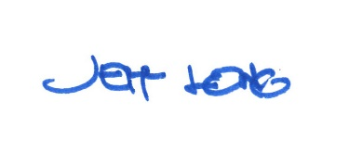

By:

Date of Meeting: May 21, 2018 Title: Historic Officer

